Nama : Nada Shafa Maisa

NIM : 20030014

Prodi : Informatika (IF)

Mata Kuliah : Pemrograman Mobile

1. Use Case Diagram “MyNilai_Nada”

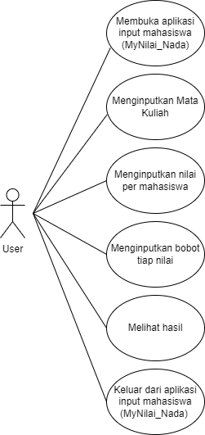

1. Class Diagram “MyNilai_Nada”

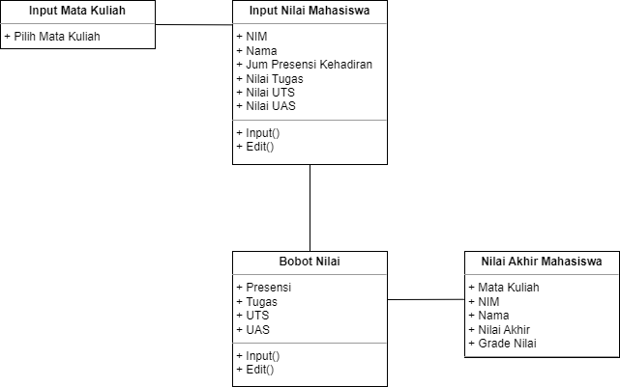

1. Activity Diagram “MyNilai_Nada

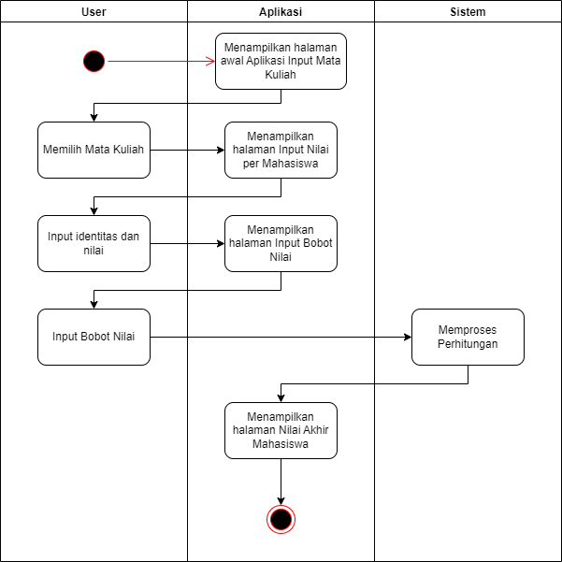

1. Sequence Diagram “MyNilai_Nada”

